Activity 2 - Task 1 - Copy the following spreadsheet into a NEW EXCEL file.
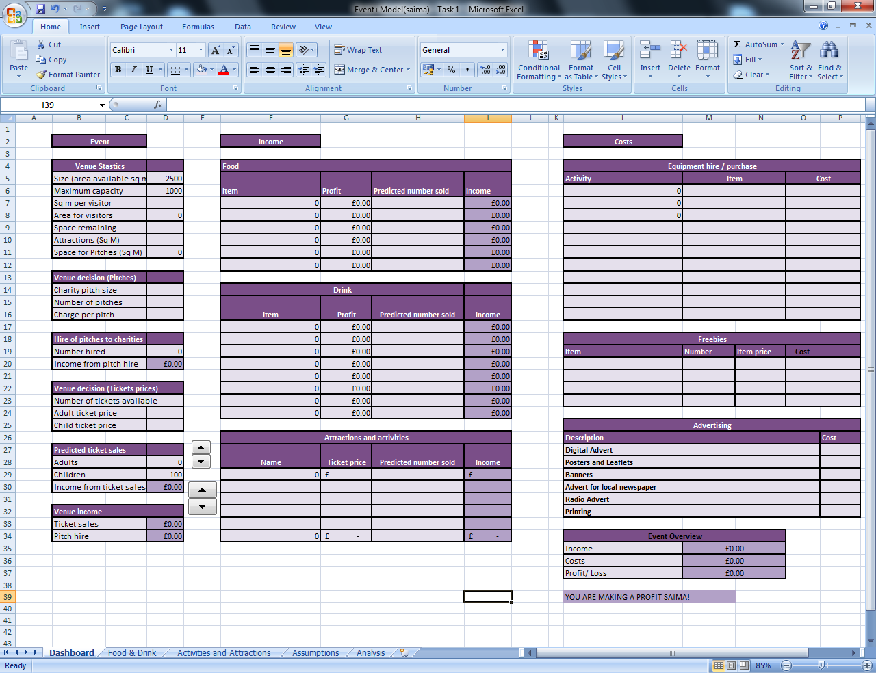
On a separate worksheet, called Food and Drink, copy the following tables:
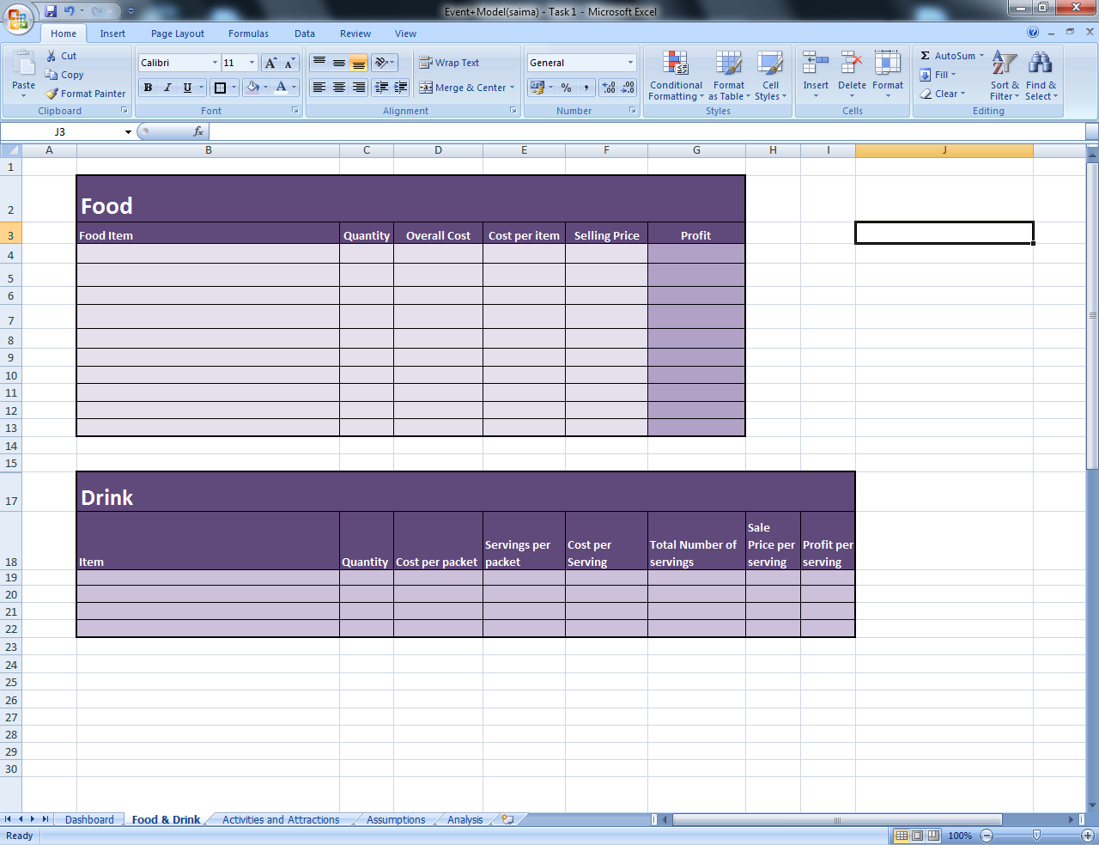
On a third worksheet called Activities and Attractions, copy the following:
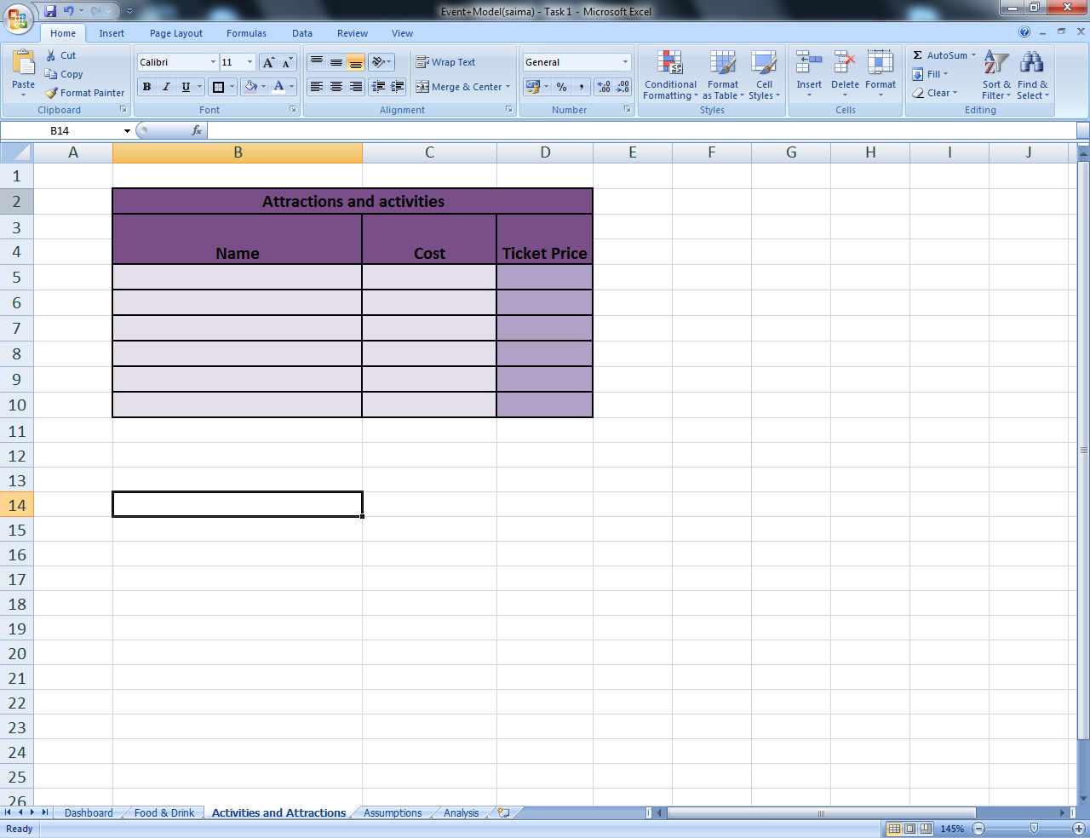

Activity 2 - Task 2 – Adding basic details to your spreadsheets
- Add the FREEBIES you will be offering to children along with the item price (how much each freebie will be costing you).
- Fill in the ADVERTISING table as shown below. You will need to research these prices first.
Note: All research needs to be placed in your Sources table.
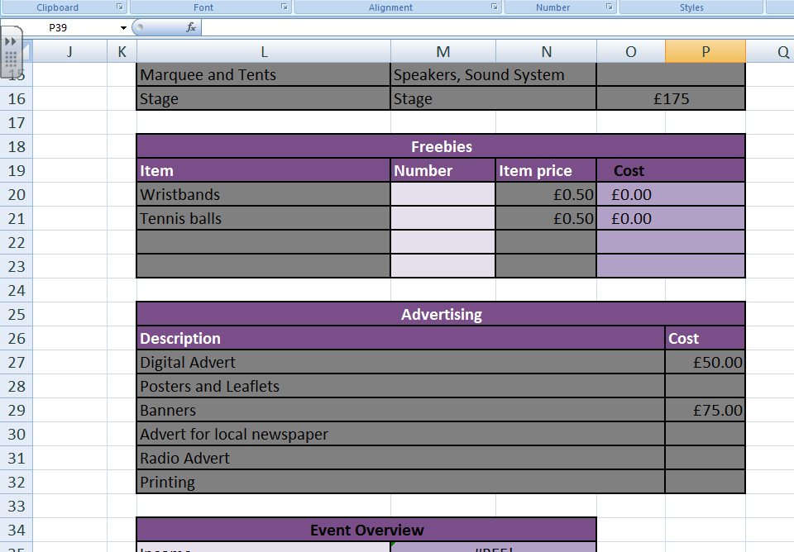

- Fill in the greyed out sections of the FOOD AND DRINK worksheet using the information you gathered from your Activity 1 review.

- Go to the main worksheet and fill in EQUIPMENT HIRE/PURCHASE table using the activities you mentioned in your Activity 1 Review and Sources table.
You can add your DJ HIRE COST to this table too.

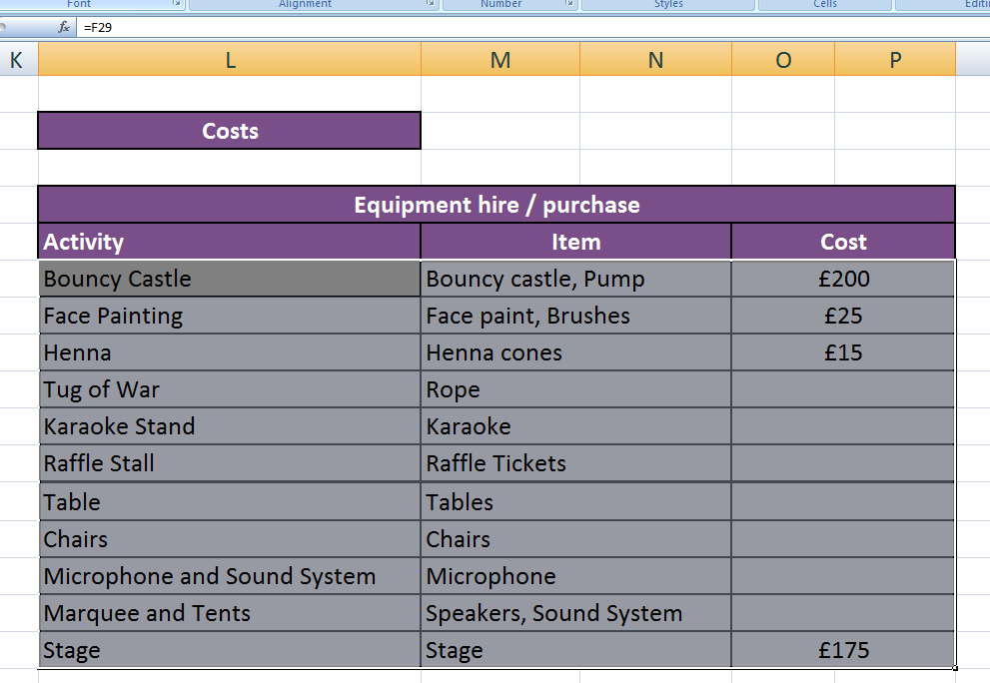

- Using the information in your EQUIPMENT HIRE table, complete the ATTRACTIONS AND ACTIVITIES worksheet:

